Computer Networks Lab

  - Session 2024 - 2028
  - Submitted By:
  - Muhammad Ayan Sajid 2024 CS 661
  - Zain Khalid 2024 CS 697
  - Minahil Ehsan 2024 CS 668
  - Syed Ayan Akbar 2024 CS 668
  - Submitted To:
  - Ms. Ghazala
  - Department of Computer Science, UET Lahore, New Campus

Table of Contents
1 Network Topology and Design Philosophy 3
1.1 Diagram 3
2 VLAN and Department Table 3
3 IP Addressing 4
4 Key Configuration Details 5
4.1 Switch Configurations 5
4.2 Router Configurations 5
4.3 Server Configurations 5
4.4 Hybrid Routing Strategy 5
4.5 Security and ACLs 6
4.6 Redudancy 6
5 Testing 7
5.1 Internet Connection 7
5.2 Campus wise connectivity 8
5.3 Server Access 8

Network Topology and Design Philosophy
This project implements scalable, three-campus network architecture (Main, New Campus, Narowal). The design adheres to enterprise best practices by separating Internal and External routing protocols.
Internal Routing: OSPF (Open Shortest Path First) Area 0 is used for high-speed, loop-free connectivity between campuses and departments.
External Routing: BGP (Border Gateway Protocol) is implemented at the Border Routers to exchange Internet routes between campuses with the ISP.

Diagram
Rules:
- Username must match an existing user in the system.
- Password must match the stored password for the username.
- User role must match the expected role for login.
- Empty username or password should be rejected.

VLAN and Department Table
Campus | Department Name | VLAN IDs.
Main Campus | Admin Block | 10
 | Server Room | Na
 | Chem-Dept | 20
KSK Campus | Admin Block | Na
 | Cs-Dept | 10
 | IBM-Dept | 20
 | BSH-Dept | 30
Narowal Campus | Admin Block | Na
 | Cs-Dept | 10
 | EE-Dept | 20
 | ME-Dept | 30

IP Addressing
Campus | Department | Subnet / Mask | Gateway IP
Main | Admin Block | 192.168.1.0 /26 | .1
Main | Server Room | 192.168.1.64 /26 | .65
Main | Chemical Dept | 192.168.1.128 /26 | .129
KSK | CS Dept | 192.168.2.0 /26 | .1
KSK | IBM Dept | 192.168.2.64 /26 | .65
KSK | BSH Dept | 192.168.2.128 /26 | .129
KSK | Admin Block | 192.168.2.224 /27 | .225
Narowal | CS Dept | 192.168.3.0/26 | .1
Narowal | EE Dept | 192.168.3.64 /26 | .65
Narowal | ME Dept | 192.168.3.128 /26 | .129
Narowal | Admin Block | 192.168.3.224 /27 | .225

Key Configuration Details

Switch Configurations
- Layer 3 Switching: The Core Switches in each campus are configured as Layer 3 devices, utilizing Switched Virtual Interfaces (SVIs) to act as the default gateways for all departmental VLANs.
- VLAN Assignment: Dedicated VLANs are created for each department (CS, IBM, BSH, Admin) to logically separate traffic and broadcast domains.
- Hybrid Routing: The switches utilize a Static Default Route pointing to the Primary Border Router for normal traffic flow, while simultaneously running OSPF to the Backup Router to ensure automatic failover if the primary link goes down.

Router Configurations
- Border Routers (Hybrid Design):
  - BGP (Border Gateway Protocol): Configured on the WAN interfaces to peer with the ISP (AS 100), exchanging external routes to simulate Internet connectivity.
  - Static & OSPF Routing: Static routes are used for the primary connection to the internal campus to prevent loops, while OSPF is enabled on backup links to maintain redundancy across the network.
- ISP Router:
  - Uses BGP to advertise global routes to all university campuses.

Server Configurations
- Network Settings: All servers are hosted in the Main Campus Server Room (VLAN 60) with static IP addresses and their default gateway pointing to the Main L3 Switch.
- DNS Server: Configured with "A Records" to resolve domain names (e.g., www.uet.edu.pk) to local web server IP addresses.
- Web Server (HTTP): Hosts the university website, accessible via the DNS domain name.
- Email Server: configured with the uet.edu.pk domain, managing user accounts for students and administration with SMTP and POP3 services enabled.

Hybrid Routing Strategy
To satisfy connectivity requirements while proving BGP implementation:
- ISP Router (AS 100): Advertises global routes to all campuses.
- Border Routers: Establish BGP neighborship with ISP to receive Internet routes.
- Internal Routers: Use OSPF to route traffic within campuses (between departments).

Security and ACLs
Access Control Lists (ACLs) enforce strict communication rules:
- Admins can communicate with other Admins.
- Admins can access the Main Server Room (Web/Email).
- Admins can access their local campus departments.
- Admins are BLOCKED from accessing departments in other campuses.
- Admins of main campus can access everything with no restrictions.

Redudancy
Primary connectivity uses Static Routes on the L3 Switch for stability. Backup connectivity uses OSPF via a shared Backup Router (Border 4). If the Primary link fails, traffic automatically reroutes through the Backup path

Testing

Internet Connection
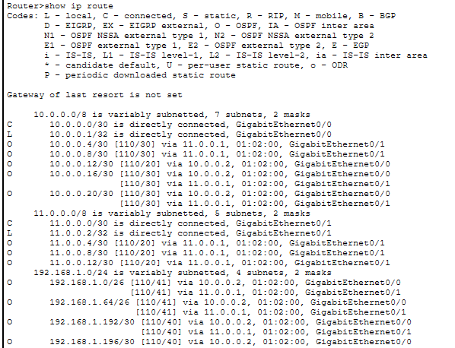
Connected successfully

Campus wise connectivity
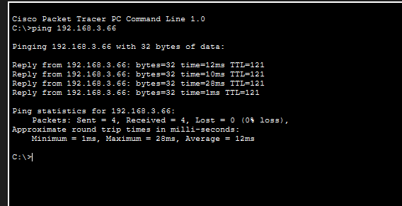

Server Access
Normal Path:
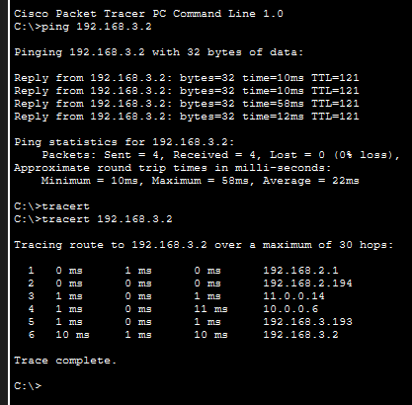
Alternate Path:
